FIND... den MÖRDER (Find the Killer)
A pattern recognition game for 2 to 4 players of age 10 and up – Duration: about 20 minutes

Object of the game  You win if you are the first player to find the german word MÖRDER  or  if you are the first player to see that it is not possible to find this word. | 36 Tiles  - 7x M  - 7x Ö  - 7x R  - 7x D  - 7x E  - 1x "The victim"

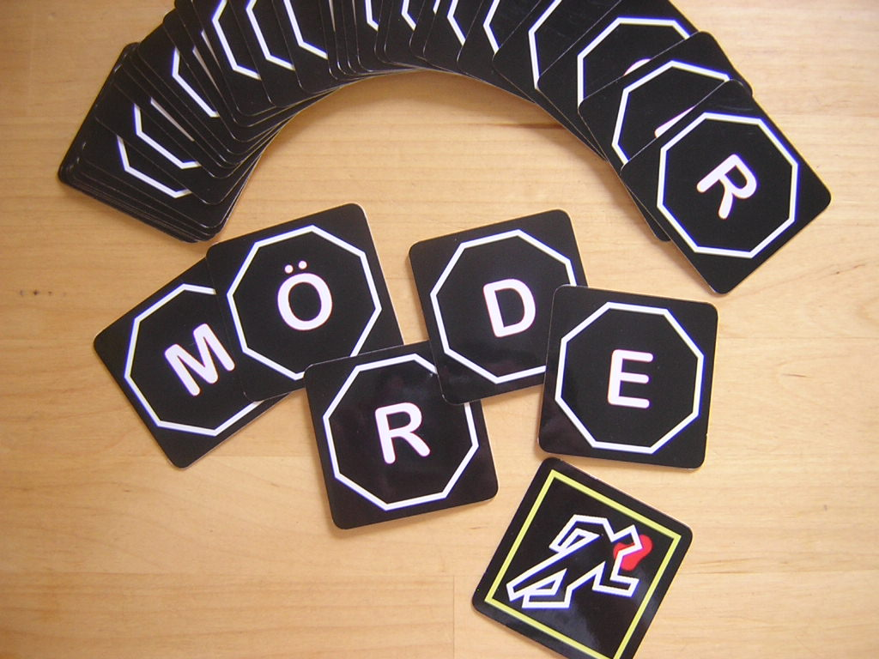
Preparation
Shuffle the tiles and put them hidden on the table forming a square of 6 x 6 tiles.

Overview
Whoever reads this decides who will take the first turn.

After each turn the respective player to the left takes his turn.

Continue to take turns in clockwise order until the winner is determined.

What do you do on your turn?

- You must turn over a tile.
- Try to find the word MÖRDER to win the game.
- If you cannot find the word, say "Next" – then the player to your left will begin his turn.

If you suspect the game to end without any player being able to find the word, you have the option to quit the game. If the other players are indeed unable to find the word until the end of the game you will be the only winner.

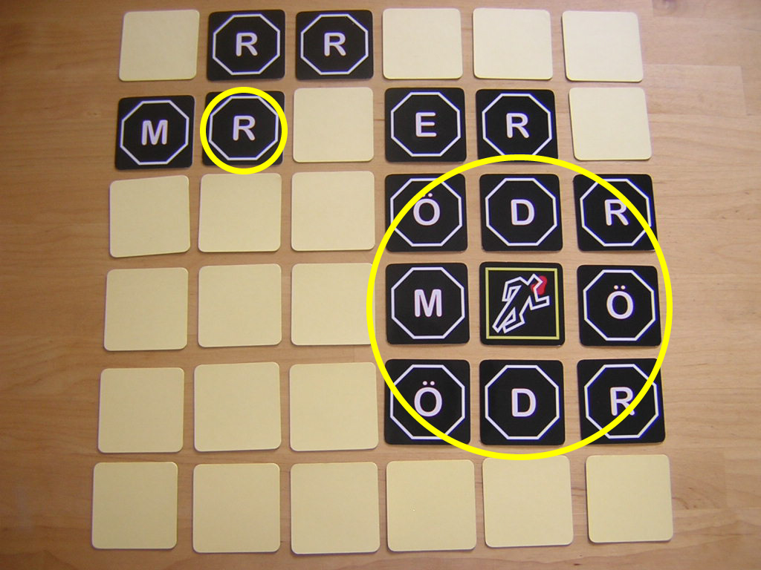
1. Turn over a tile
Normally you turn over only one tile. If you uncover a letter (like the letter "R" in the picture) you continue with the next step.

If you uncover the body – as in the case in the lower right corner of the picture – you immediately also turn over all (horizontally, vertically and diagonally) adjacent tiles.

You must keep the orientation of the tile as is after turning it over. It is possible that the letters face in different directions.

2. Try to find the word MÖRDER
After turning over a tile (or several tiles in the case of the body) try to find the word MÖRDER.

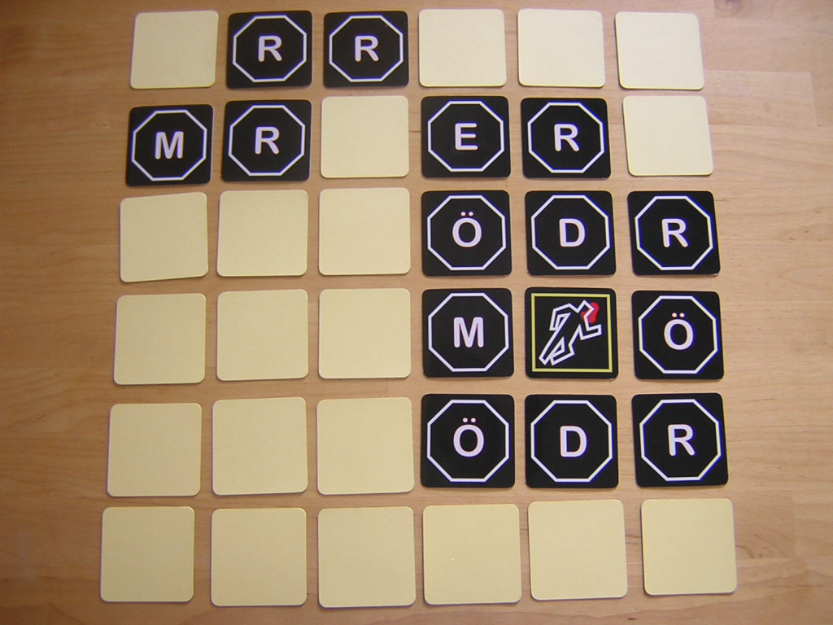
You win, if you detect six tiles showing the letters of the word MÖRDER if these tiles form a (diagonally, horizontally and/or vertically connected) chain in the correct order.

In this situation it is not yet possible to build such a chain.

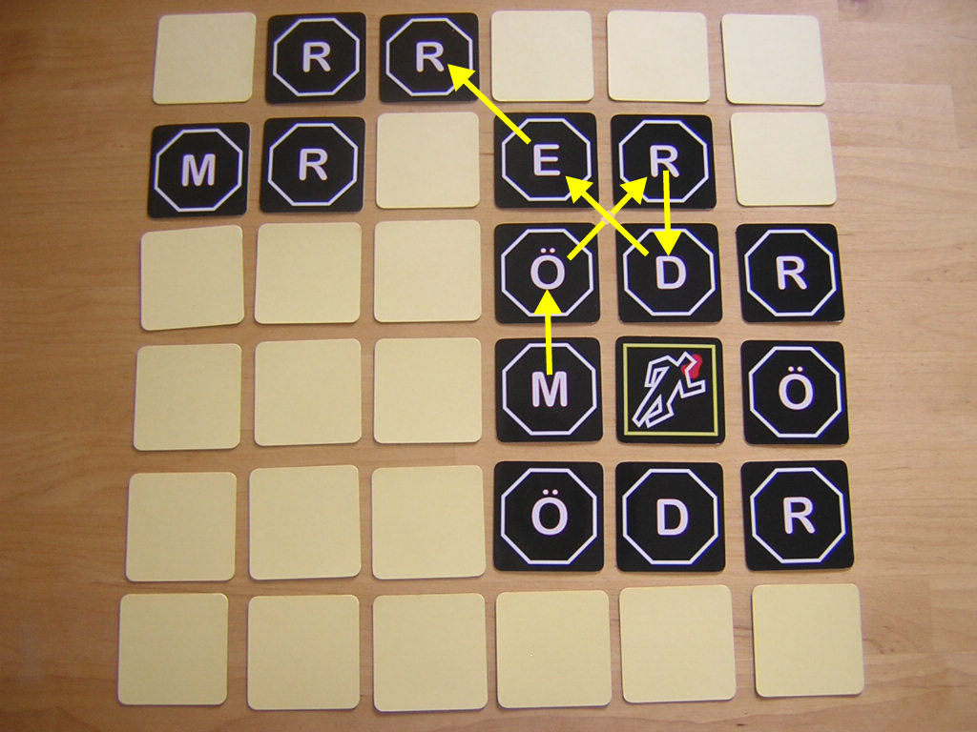

In this situation you would win the game.

A chain is valid even if it is crossing itself as long as there are six different tiles in it.

3. Next
If you are unable to build the word MÖRDER say loud "Next!" so that the next player can start his turn.

Quit the game
In your opinion it is not possible to build the word MÖRDER on the table?

Then forfeit your turn and say " Ich steige aus. Es gibt keinen Mörder!". (YES. It has to be in German.)

You take no further turns. The other players continue to play – nobody is allowed to quit the game after the first player decided to quit. If the other players indeed are unable to build the word MÖRDER, you are the only winner of the game.

End of game
The game ends with the victory of the player who is the first one to find the word MÖRDER.

Nobody was able to build the word after turning over the last tile? In this case the player wins, who quit the game.

If nobody quit the game, there is no winner.

(Too) Elementary?
O.K. – whoever is interested in a more challenging variant - visit www.erlkoenig.net.

Have fun!

